BYOP PROJECT REPORT
Fundamentals of AI & ML | VITyarthi

Sentiment Analyzer for Product Reviews
Analyzing customer feedback the smart way

Student Name | Dhairya Agrawal
Program | B.Tech — Artificial Intelligence & Machine Learning
University | VIT Bhopal University
Platform | VITyarthi
Course | Fundamentals of AI & ML
Module | CO5 — Bring Your Own Project (BYOP)
Submission Date | March 2026

1. The Problem I Wanted to Solve

Online stores get tons of reviews daily. Reading them all manually takes forever. Shop owners need to know quickly if customers like their products or not.

I built a simple tool that reads any product review and says POSITIVE, NEGATIVE, or NEUTRAL.

Real example: When I shop on Flipkart, I always check reviews first. This tool does that job automatically.

2. Why I Chose This

Sentiment analysis is everywhere — Amazon uses it, Flipkart uses it. Small shops cannot afford fancy tools though. My simple Python program helps them understand customer mood fast.

It is also a perfect fit for this course — it uses basic Python concepts like lists, loops, and functions. No complex ML needed.

3. How It Actually Works

Step by step:

- User types review: "Great phone, fast delivery!"
- Clean text: lowercase + remove punctuation → "great phone fast delivery"
- Split words: ["great", "phone", "fast", "delivery"]
- Check each word against my positive / negative lists
- Handle "not good" → flip score because of negation
- Compare scores → POSITIVE if more + than -

Core logic:

if word in positive_words:
if previous_was_negation: neg_score += 1
else: pos_score += 1

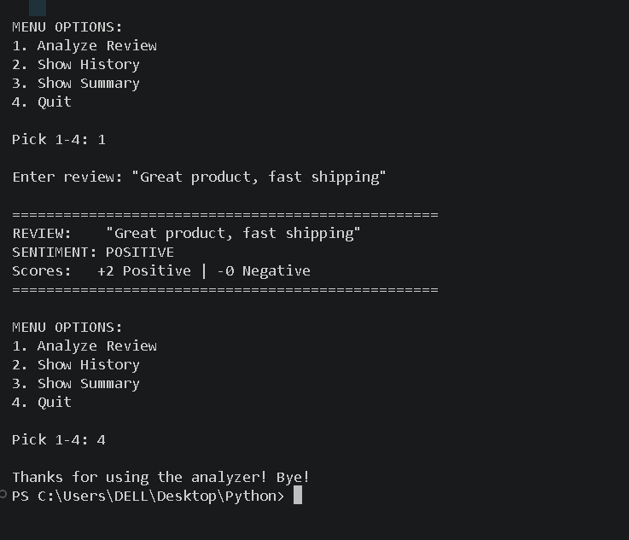

Features I added:
- Menu system (1 = analyze, 2 = history, 3 = summary)
- Remembers all reviews analyzed in the session
- Shows summary at the end: "5 positive, 2 negative, 1 neutral"

4. Decisions I Made During Coding

- No libraries! Pure Python only. Runs anywhere.
- Added negation handling after testing showed "not bad" was giving wrong result.
- History feature makes it practical for shop owners analyzing 10+ reviews at once.

5. Problems I Faced and Fixed

Hardest part: "not good" was scoring positive! Fixed it by checking the previous word before scoring.

Punctuation was breaking word matching — "great!" was not matching "great". Fixed this with a clean_text() function that strips punctuation before analysis.

Mixed reviews like "good product, bad support" score neutral — this is a known limitation of the simple keyword approach. More advanced techniques like machine learning would be needed to go deeper.

6. What I Learned

- Text preprocessing matters a lot in AI — cleaning data before using it makes a big difference.
- Simple rules can do smart things — you do not always need a complex model.
- Real projects have limitations — this tool cannot detect sarcasm yet.
- Breaking code into functions keeps things much cleaner and easier to fix.
- Word choice matters — I had to think like a customer writing a review to pick the right words for my lists.

7. Final Thoughts

The program works! I tested it with these examples:

- "Great product, fast shipping" → POSITIVE
- "Battery died in 2 days" → NEGATIVE
- "Not bad for the price" → POSITIVE

Next step would be building an ML model for this, but for BYOP this hits the target perfectly. It solves a real problem, uses course concepts, and is something I can demo and explain fully.

References

- Course slides on rule-based systems — VITyarthi Fundamentals of AI & ML
- Python official documentation — python.org (string handling methods)
- Amazon.in and Flipkart.com product reviews (source of real-world word ideas)

